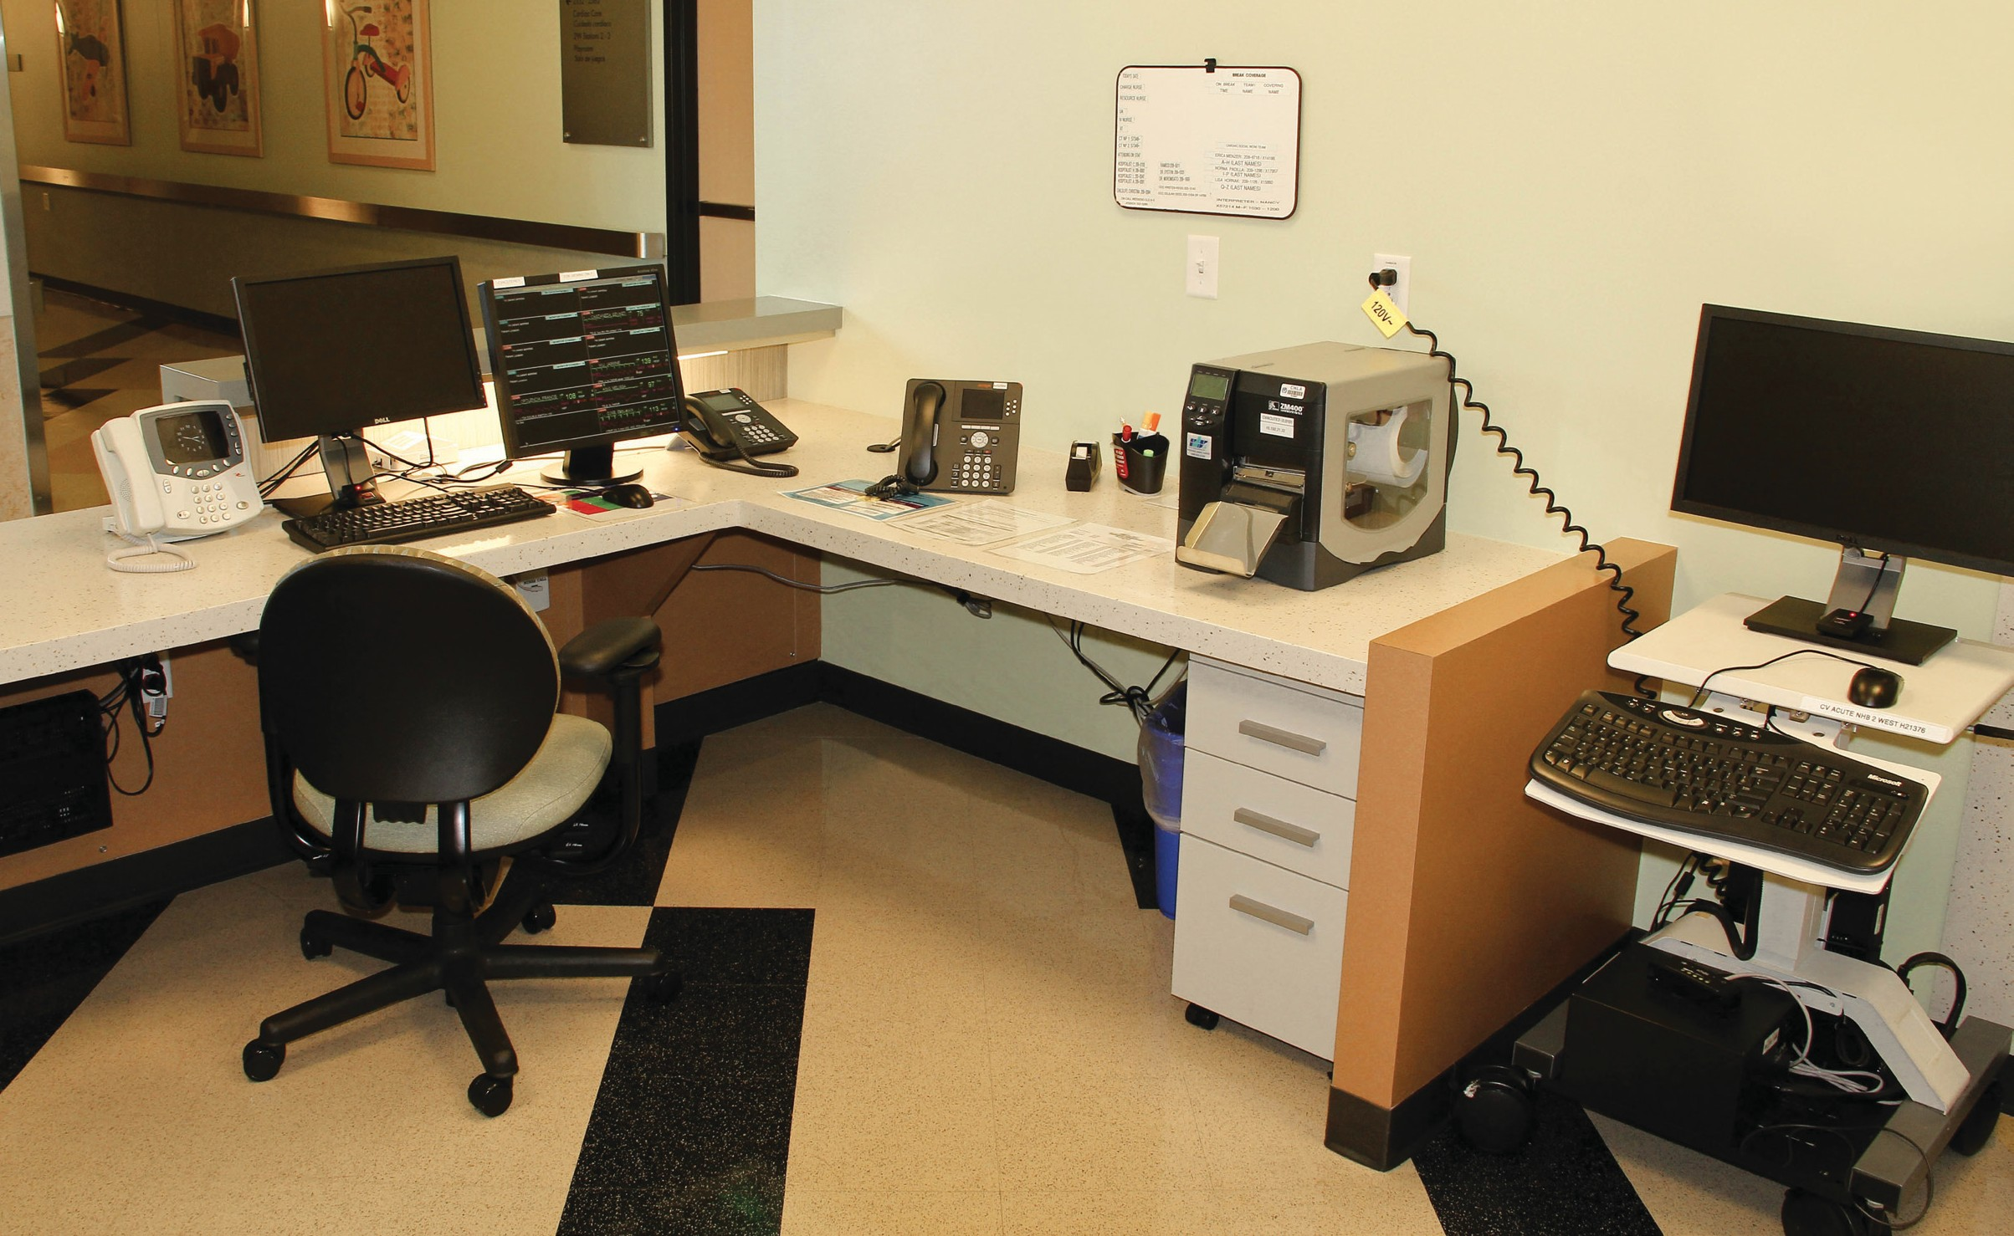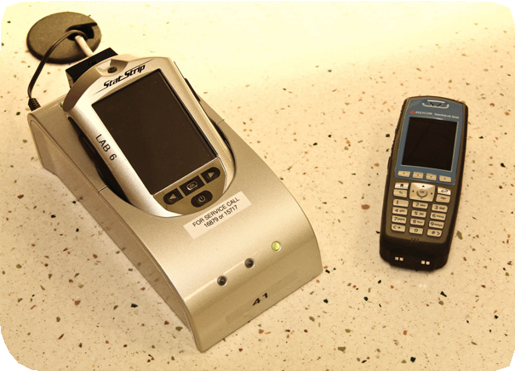

**Cleaning High-Touch Surfaces in Patient Care Areas**

## 4 2

6 2 4

3

1

1

5

3

8

7

**NURSES STATION**

v

### Equipment Approved to Clean with PDI Super-Sani Wipe: 2-Minute Contact Time

#### Desks and hard surfaces of chairs

1. Desk phones
2. Computer keyboards
3. Computer monitors
   * Clean only if visibly soiled
   * After contact time is elapsed—MUST clean touch-screen with water and wipe dry

#### Filing cabinets

1. Intercom system
2. Glucometer or Epoque Laboratory Handheld Device

**Equipment Approved to Clean with Dispatch Bleach Wipe: 5-Minute Contact Time for *Clostridium Difficile*, 1-Minute Contact Time for all other Organisms**

1. Polycom phones

**Cleaning High-Touch Surfaces in Patient Care Areas**

6 9

4

2

1 7

5 8

3

2

**STANDARD PATIENT ROOM – MEDICAL SURGICAL UNIT**

### Equipment Approved to Clean with PDI Super-Sani Wipe: 2-Minute Contact Time

#### Phone

1. Parent chair and parent sleeping couch
2. Storage cabinet
3. Patient bed or crib
4. Over-bed table
5. GetWellNetwork console
   * Clean only as needed if visibly soiled
   * After contact time is elapsed—MUST clean touch-screen with water and wipe dry

#### Large-volume IV pump/ IV pole

1. Privacy curtain
   * If patient is on Contact, Combined-Droplet, or Combined-Airborne Isolation curtain must be changed during discharge cleaning
   * If patient on Standard Precautions curtains are changed every six months

#### Patient monitor with touchscreen

* + After contact time is elapsed—MUST clean touch-screen with water and wipe dry

v

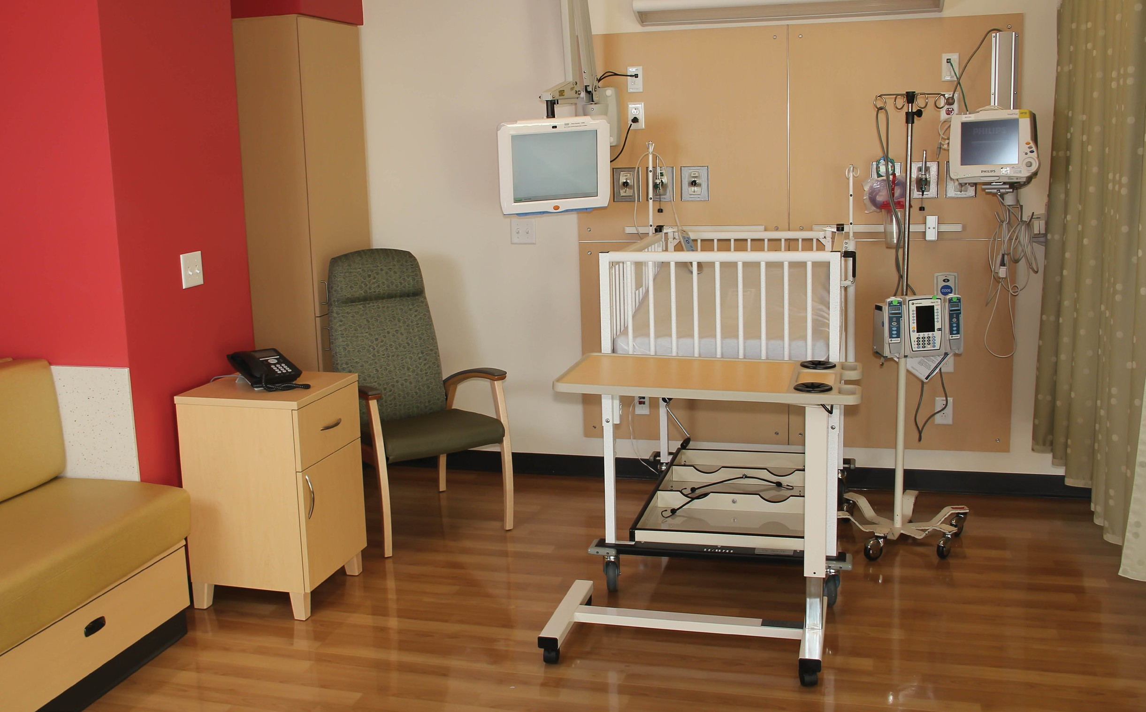

### If patient isolated for infection with *Clostridium Difficile*, Norovirus or Vancomycin-Resistant Enterococcus please use Dispatch wipe as cleaning agent.